 Wednesday, September 5th dine at El Rodeo on Fox Rd. Please mention MPLT when paying for your lunch or dinner, and a percentage will go toward supporting the MPLT.

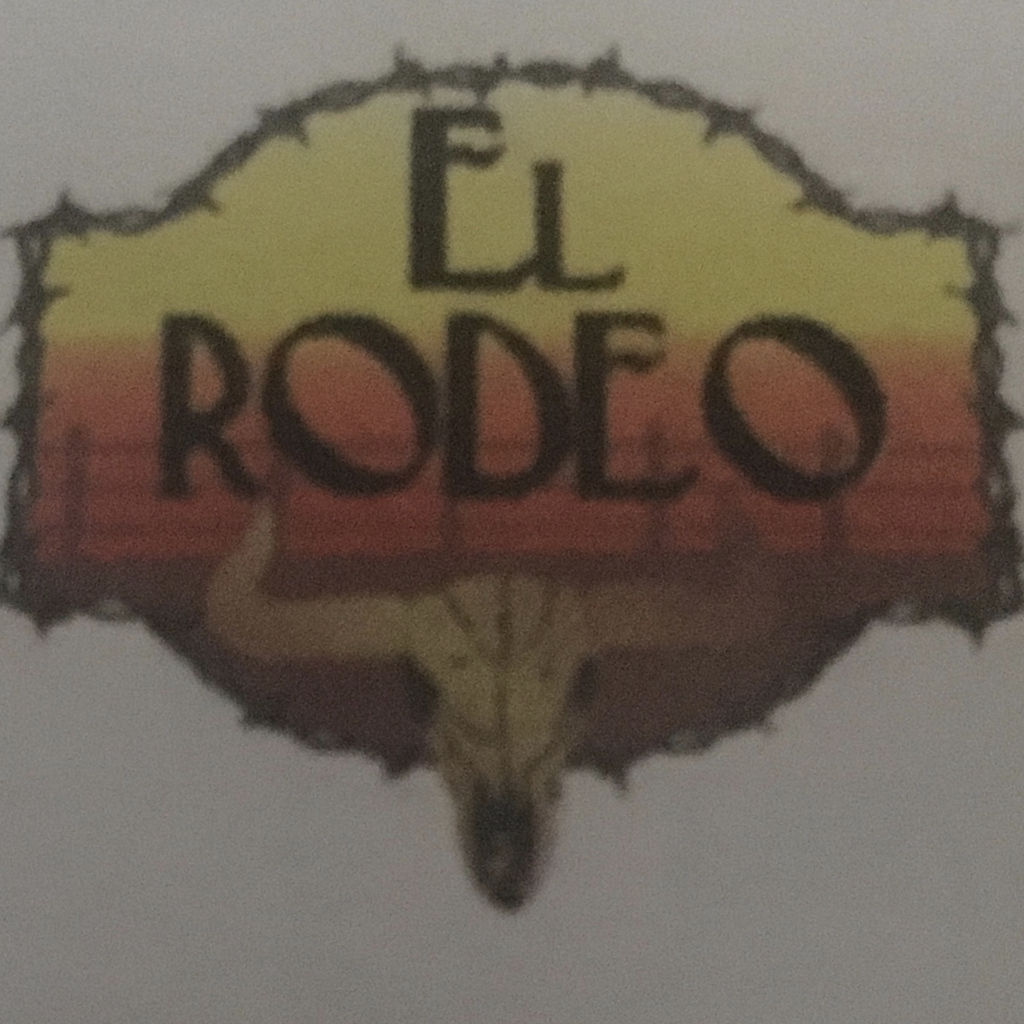

11677 Fox Rd, Indianapolis, IN 46236
(317)823-5136
Wednesday, September 5th 11:00am – 10:00pm

