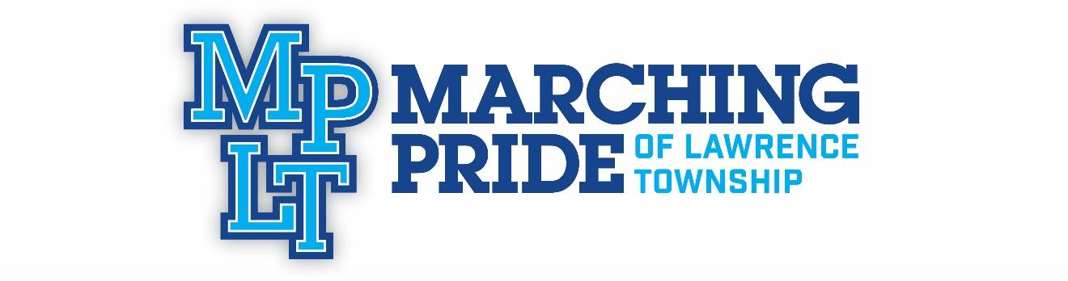
UPDATED SEMI-FINALS ITINERARY
Bands of America Grand National Championships
Saturday, November 16th , 2019

Saturday, November 16th, 2019

8:00am Report Time
8:30am Rehearsal
10:30 am Rehearsal Ends. Eat. Change into uniform
11:15am Pre-Tune process begins
12:40pm Meet in band room
12:50pm Load buses
1:00pm Depart for Lucas Oil Stadium
1:30pm Enter SW lot
2:20pm Enter SW tunnel
3:30pm Perform! We will stay to watch the remaining groups and the Semi-Finals Awards
5:00 pm Semi-Finals Awards
If we make it, all times will be announced after the 5:30 pm directors’ meeting
If we don’t make finals, we will celebrate the end of the season prior to dismissal.
6:45 pm Earliest transit to Southwest Tunnel
8:00 pm First possible performance time if we make finals.
11:30 pm Finals Awards
12:00 am Load buses
12:15 am Depart for LC
12:45 am Arrive at LC. Put all equipment away, change out of uniform, and CELEBRATE
AN AMAZING SEASON of growth!! Watch the video and final dismissal by ALL SENIORS!
2:30am Approximate time of dismissal

General Information Regarding the Bands of America National Championships
- This is the Bands of America Grand National Championships, meaning that there are over 93 bands from all over the United States competing for 30 to 36 Semi-finalist spots. From those 30 to 36 semi-finalist bands, the top scoring 12 bands in Saturday’s Semi-finalist round of competition will be selected for Saturday evening’s Grand National Finals. We will not know if we have been selected as a semi-finalist or what our performance time for semi-finals is until after the 8:30 pm awards announcements on Friday evening (the semi-finalists announcement will take place around 9:00 pm).
- Semi Finals begin at 7:00 am Saturday morning and the last performance will conclude by 4:45 pm. At 5:00 pm a full semi-finalist awards ceremony will take place to announce the top three in each classification (A, AA, AAA, AAAA), as well as caption awards for music, visual and general effect. MPLT is in class 4A. After that those awards, they will announce the twelve National Finalists.
- If we make finals, we will follow the same procedure we did for the Indy Super Regional Finals. It will be a late night. If we do not make finals we will celebrate immediately upon learning those results.
- Tickets: There are many ticket options available for this two-day event. Please follow the link below for this information:
https://marching.musicforall.org/event/grandnationals19/
- A full schedule of all of the bands attending Grand Nationals is available on the musicforall.org website: https://www.musicforall.org/

